PICTURES TAKEN AT THE JIV TO NAOC, EGBEGORO 11T FLOWLINE AT OMOKU COMMUNITY, ONELGA, RIVERS STATE.

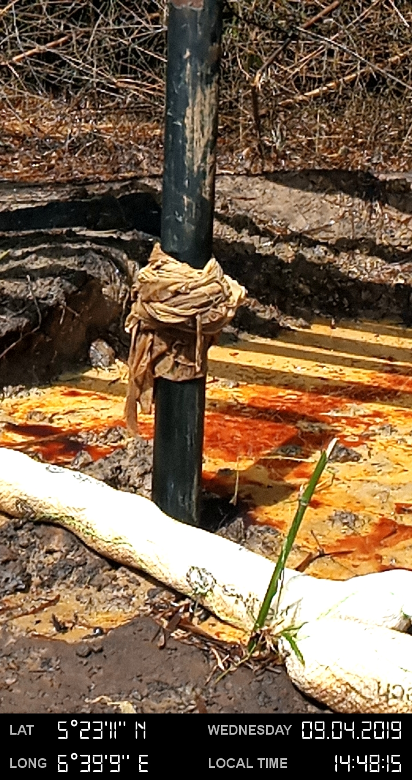
The spill point was covered with rag after the flowline was shut-in. The area around the spill point was heavily impacted. River boom was used to contain the spill from further spread.

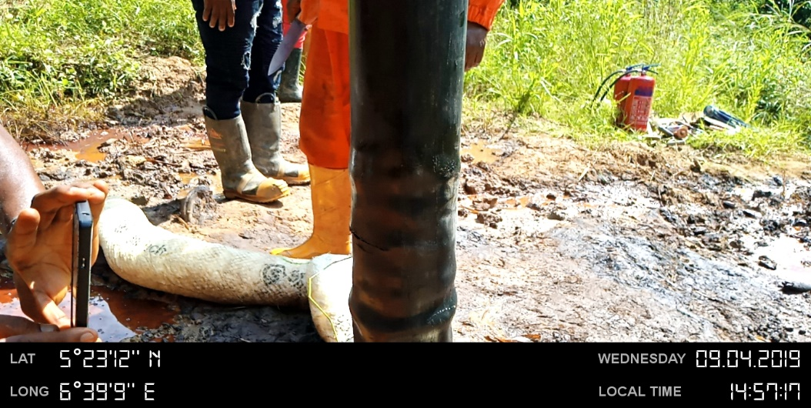
A 80mm hacksaw cut on the line

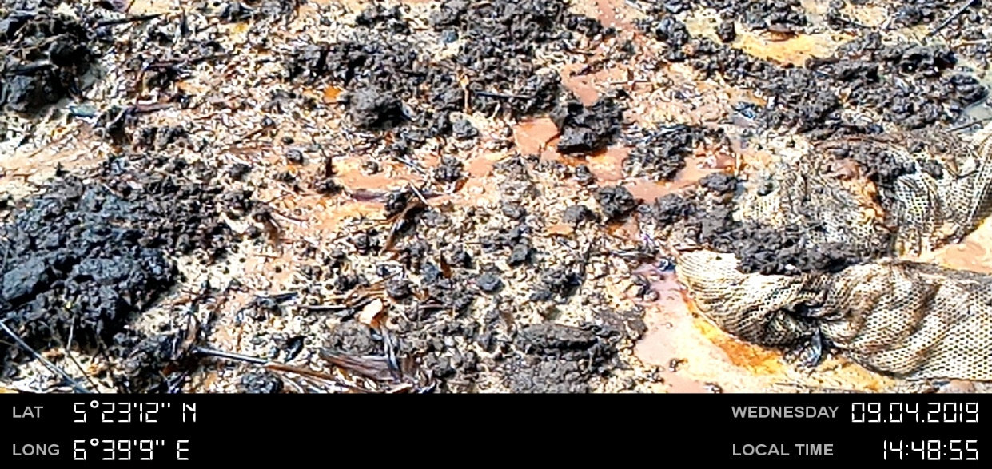
Area around the spill point was heavily impacted

